

Automation Technology 1

Lab 2: Basic Ladder Logic Design with Counters
Lecturer: Eoin Byrne
Submission Date: To be confirmed during the semester

Section 1 – Introduction to Simple Ladder Diagrams

Abstract:
The aim of this section is to familiarise students with basic timer and counter functions alongside operations and the programming of a simple ladder diagrams. Students will download their programs to the Mitsubishi FX3G PLC, test, and verify their programs to ensure satisfactory operation.

Objective:
To gain practical experience constructing ladder diagrams and programming a PLC using timers and counters for outputs for various Scenarios.

Automation Problem 1:

Using GX Works 2 design a ladder Logic program to turn on a Lamp on a Traffic light Station (Y0) when the Start Button(X0) is pressed five times.

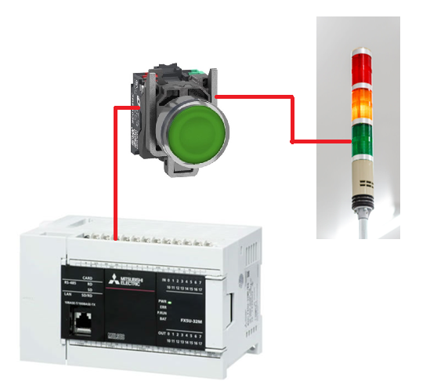

1: Design the Ladder Logic
2: Test on Simulator to ensure correct Operation
3: Download to PLC to Verify correct Operation
4: Screen Shot of ladder Diagram explaining Operation
( 10 Marks)

Automation Problem 2:

Design a PLC Program to meet the following System Requirements
- Create a counter that counts the number of times X0 has been Pressed
- When X0 has been pressed four times, Green on Traffic Station should Luminate.
- When X1 is pressed, the counter should reset an Lamp Y0 should Turn off

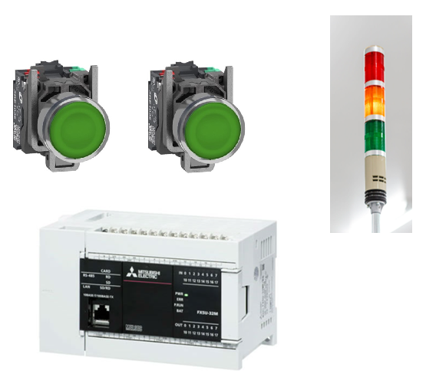
1: Design the Ladder Logic
2: Test on Simulator to ensure correct Operation
3: Download to PLC to Verify correct Operation
4: Screen Shot of ladder Diagram explaining Operation
( 15 Marks)

Automation Problem 3:

Design a PLC Program to meet the following System Requirements
- Lamp Y0 turns on are X0 is pressed five times and tuns off again after an additional five presses of X0
- The Process can be Constantly repeated.

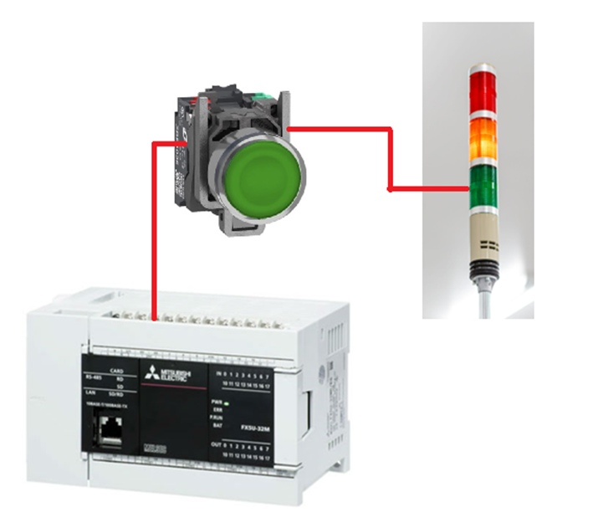
1: Design the Ladder Logic
2: Test on Simulator to ensure correct Operation
3: Download to PLC to Verify correct Operation
4: Screen Shot of ladder Diagram explaining Operation
( 10 Marks)

Automation Problem 4:

Design a PLC Program to meet the following System Requirements

- When X0 is pressed four times followed by five presses of X1, output lamp Y0 should energize.

- The lamp mustn’t turn on if either X0 or X1 are pressed 9 times.

- When both X0 and X1 are pressed the counter should reset

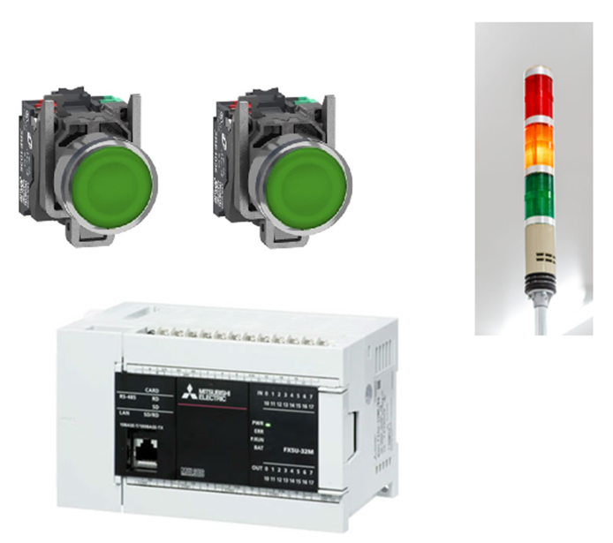
1: Design the Ladder Logic
2: Test on Simulator to ensure correct Operation
3: Download to PLC to Verify correct Operation
4: Screen Shot of ladder Diagram explaining Operation
( 25 Marks)

Automation Problem 5:

Design a PLC Program to meet the following System Requirements
- When the PLC is turned on there should be no lights on traffic light station

- When X0 is pressed Y0 should energize

- When X0 is pressed again the next lamp should turn on (Y1)

- When X0 is pressed again the next lamp should turn on (Y2)

- When X0 is pressed again the next lamp should turn on (Y3)

- Finally when pressed again all traffic lights should be off and the process should be able to start again
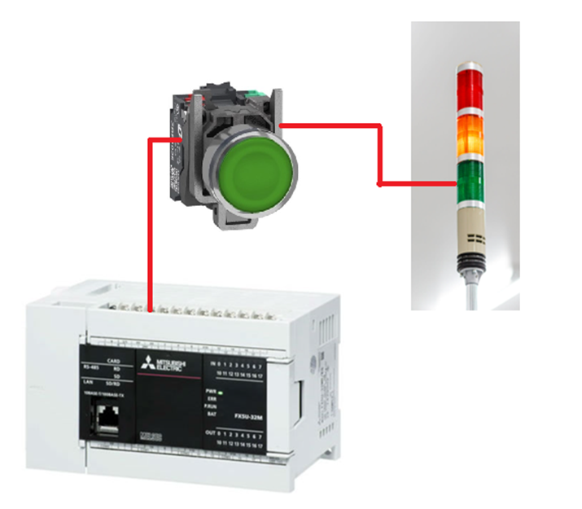 ( 30 Marks)

Finally write a Lab Conclusion and tie this into a practical example that you could automate based on the counter function explain clearly.
(10 Marks)

